SEEM3650 Report

Yan Tsz Wun 1155160184

Wai Tsz Him 1155159299

Leung Ka Ko 1155159158

**a. Executive summary**

This report aims to investigate the sources and trends of air pollution in Hong Kong and predict future air quality to inform policy decisions about emissions regulations, public transportation, and urban planning. Our analysis focuses on identifying the major sources of air pollution that may affect the Air Quality Health Index (AQHI) level and major pollution hotspots. We utilized an unsupervised learning approach and regression to analyze the data and make predictions about future air quality. Our proposed solution involves targeted policy interventions for reducing pollutant emission and improving the health of citizens.

We found out that the annual traffic flow inside a district is highly correlated with the AQHI of the district. We found out that the correlation between traffic flow and AQHI is very high, which is 0.88. On the other hand, other factors like population density are not highly correlated with AQHI, in which the correlation is just 0.51 to 0.52.

We propose three solutions to deal with the situation. The first one is increasing the usage of public transport. This method can greatly improve air quality as the number of vehicles on the road is reduced. Another one is to encourage people to change from diesel cars to electric or fuel cell vehicles. With these two kinds of vehicles being harmless to the environment as they have zero emission or emit water vapor respectively, this method can greatly reduce the air pollution on the road. The third solution is to regulate pollution from diesel and petrol vehicles. We will use the European exhaust emissions standard as it provides clear guidelines to follow. For newly registered vehicles, they should follow the newest standard which is Euro 6. For already registered vehicles, they will be phased out once they reach their re-registration time or commercial lifespan.

As our data collected is from 2021 to 2022, prediction of future AQHI may not be accurate as we suffer from the pandemic in these two years. Commercial activities were halted, leading to a reduction in air pollution. In the near future, when our society recovers from the pandemic, the AQHI may increase significantly. Moreover, as we want to investigate the air quality around us, we do not include other standards. Other places outside the city are not studied as they are far from the air quality collection stations that are used to calculate the AQHI. Thus, we may not get the full picture of the air quality in Hong Kong.

Our project aims to improve the AQHI in Hong Kong. Our suggestion is to focus on reducing traffic flow in the city. This may lead to overlooking of other factors such as population density. Therefore, policy makers should also balance factors that we do not consider in this report.

**b. Description of the data and the question(s) under investigation**

The data we used in this project includes the AQHI. The AQHI informs you of the short-term health risk of air pollution and helps you take precautionary measures to protect your health. The AQHIs are reported on a scale of 1 to 10 and 10+ and are grouped into five health risk categories. 1 to 3 means the risk is low, 4 to 6 means the risk is moderate, 7 means the risk is high, 8 to 10 means the risk is very high, and 10+ means the risk is serious [1]. The lower the AQHI is, the better the air quality is. As the data provided by the government is divided into every hour every day, we calculated the annual daily average in order to match the data of traffic flow. FIgure 1 shows the annual daily average AQHI in different districts.

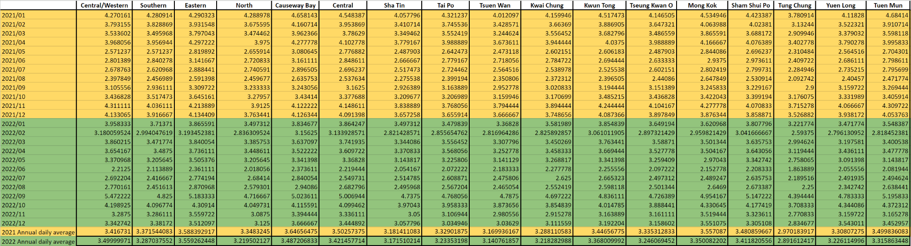

Fig. 1: Table for data of Monthly and Annual Daily Average of AQHI by districts in 2021 and 2022. [2]

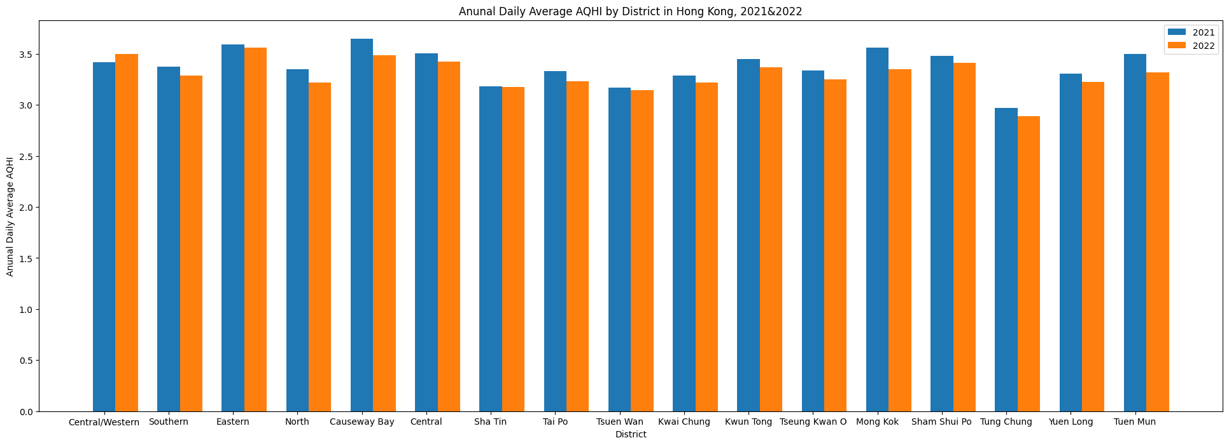

Fig. 2: Bar chart of annual daily average AQHI by districts in 2021 and 2022. [2]

The next data used is the annual average daily traffic flow in different districts in 2021. We took the traffic flow in the center of the district so as the recorded traffic flow can be represented as close to reality as possible. In some areas, we use multiple data points to show a better picture of the annual average daily traffic flow as those places are more urbanized. Figure 3 is a table showing the data of annual average daily traffic flow of different districts.

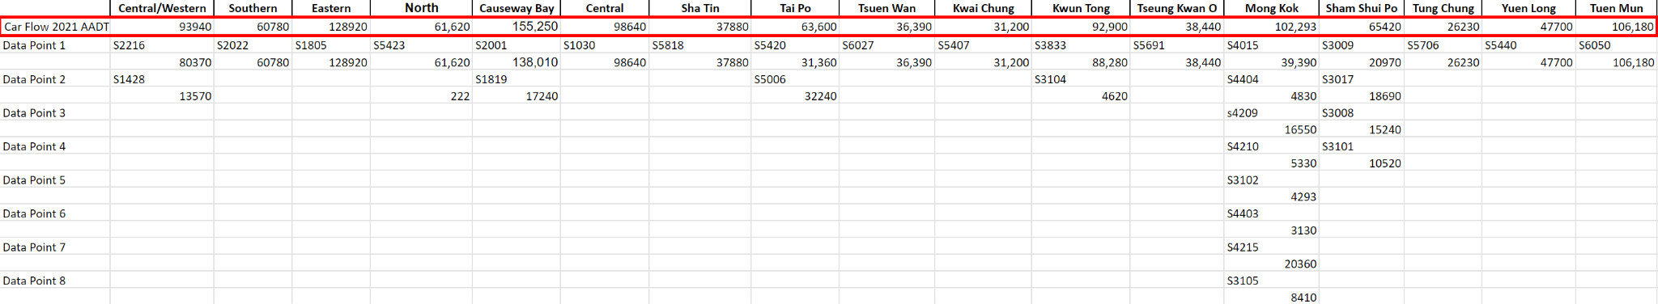

Fig. 3: Table for data of annual average daily traffic flow in different districts in 2021. [3]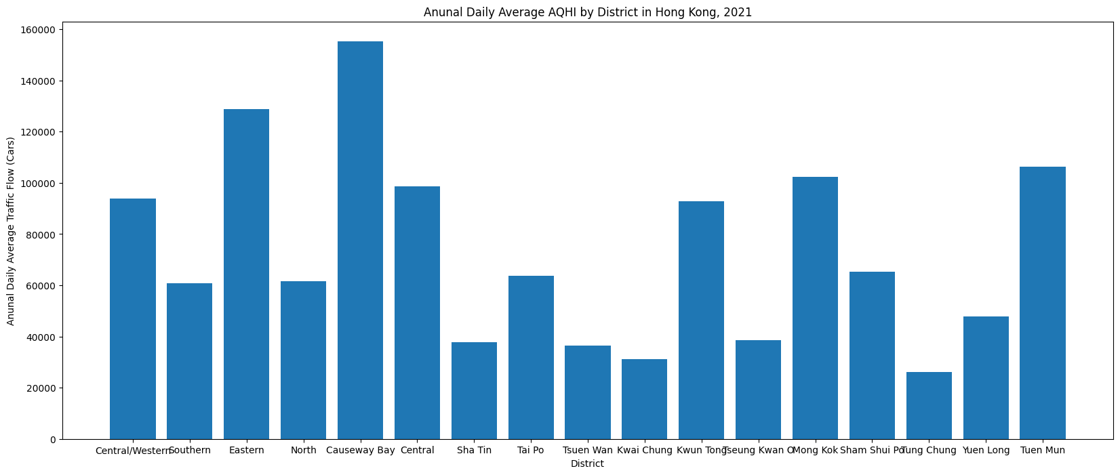

Fig. 4: Bar chart of Annual Daily Average Traffic Flow by District in 2021. [3]

The last data that we want to examine is the fine suspended particulates, known as PM2.5. This is a kind of pollutant in which the particles have a diameter of 2.5 μm or less. It can be inhaled by humans and therefore harmful to human bodies. Below is a table showing the amount of fine suspended particulates (µg/m³) in the air in different districts.

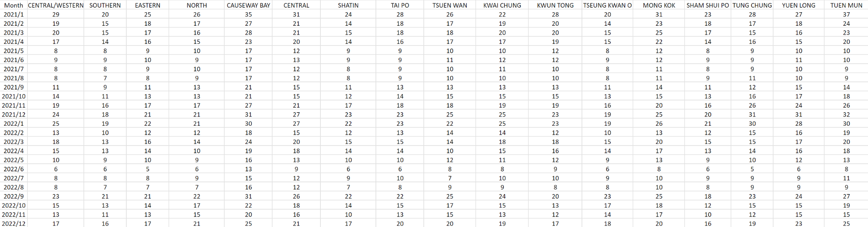

Fig. 5: Table for fine particulates in the air in districts in Hong Kong [4]

Population density can be another factor that can affect the air quality as more people can lead to higher pollution rate. Therefore, we also want to study the effects on air quality caused by population density. Below is a table showing the population density of different districts.



Fig. 6: Table of population density in Hong Kong in 2021 and 2022 [5][6]

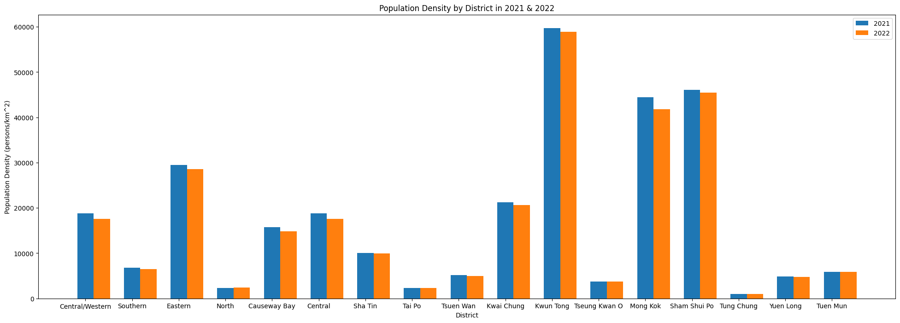

Fig. 7: Bar chart of population density by district in Hong Kong in 2021 and 2022 [5][6]

Our question under investigation is how we can reduce air pollution by analyzing sources and trends of various factors like traffic flow and population.

**c. List of methods that you have tried and their descriptive results**

We used a scatter diagram to represent the relation between traffic flow and AQHI. As we can see in figure 8, the more the number of cars there are, the higher the AQHI is. The traffic flow and AQHI has positive correlation at high correlation coefficient 0.88. The red line represents the linear regression line between 2 datasets.

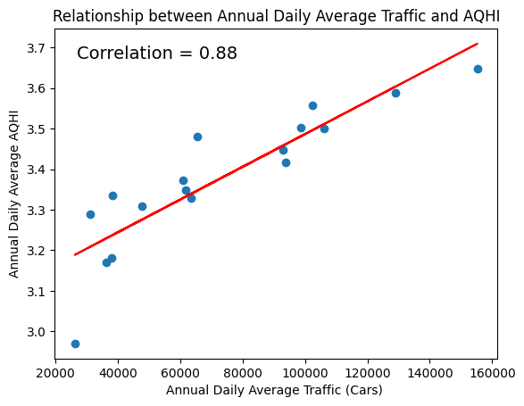

Fig. 8: Scatter diagram of AQHI and traffic flow

For the population density, we also used the same method to show the relation between it and AQHI in figure 9 and 10

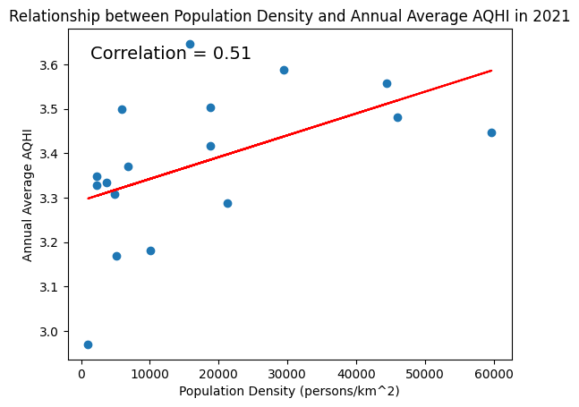

Fig. 9: Scatter diagram of population density and annual average AQHI in 2021

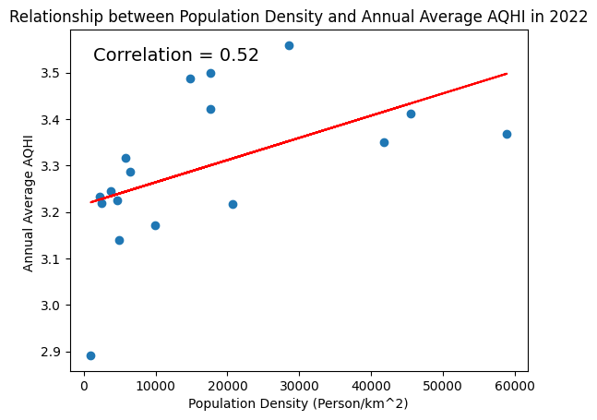

Fig. 10: Scatter diagram of population density and annual average AQHI in 2022

From these diagrams, we can see that traffic flow, in which the correlation coefficient is 0.88, affects AQHI more than population density, in which the correlation is 0.51 and 0.52. As a result, in our final solution package, we will focus on how to reduce traffic flow to alleviate its impact on air pollution .

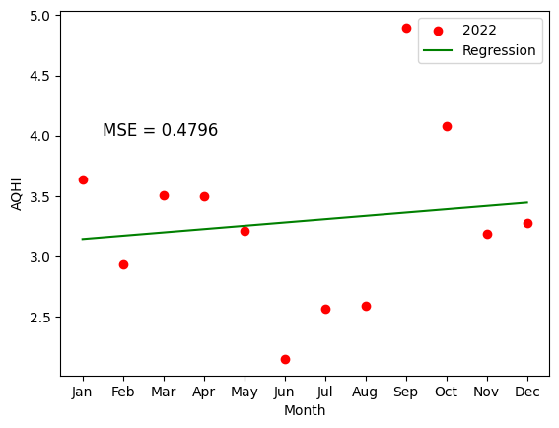

Fig. 11: linear regression of monthly average AQHI in 2022

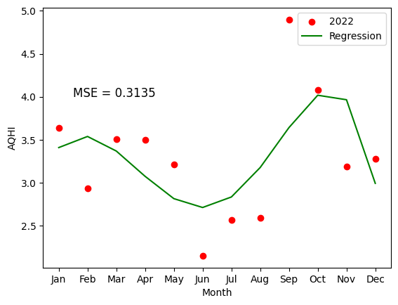

Fig. 12: polynomial regression(degree 5) of monthly average AQHI in 2022

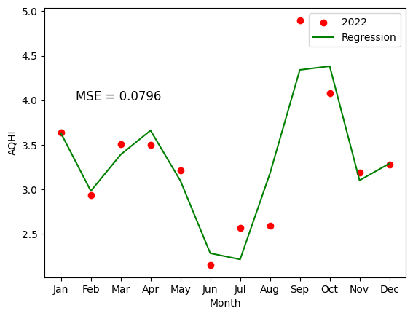

Fig. 13: polynomial regression(degree 8) of monthly average AQHI in 2022

For fig. 11-13, there are three models to predict 2023 monthly average AQHI,by linear regression, degree 5 polynomial regression and degree 8 polynomial regression. We will choose degree 8 polynomial regression to predict future AQHI. Because linear regression is too flat, it cannot show the rapid changes in June and September. And degree 5 polynomial regression cannot show the rapid changes in September. Degree 8 polynomial regression can follow the rapidly changes on those months and the mean square error also rapidly decreased , so we will choose degree 8 polynomial regression to predict future AQHI.

**d. Describe the final solution package that you propose and their detailed results**

Our final solution package aims to reduce traffic flow in districts that have the worst air pollution. One of the solutions is to encourage the usage of public transport. Not only does using public transport greatly reduce the citizens’ carbon footprint, it also reduces traffic congestion, giving a safer and more pleasant environment for the public. For instance, while the maximum capacity of a car is typically around 5 passengers, a double-decker bus can accommodate approximately 100. We can effectively reduce air pollution by replacing 20 cars with one bus.

Another solution is to encourage the shift from diesel and petrol vehicles to electric or fuel cell vehicles. Since electric vehicles do not emit pollutants on the road, changing to them would eliminate the amount of pollutants produced by diesel vehicles. For the fuel cell vehicles, they only emit water vapor, which is harmless to the environment, as they operate on hydrogen.

An additional solution is to regulate pollution from diesel and petrol vehicles. One good standard is the European exhaust emissions standard. This standard gives clear numbers on the amount of pollutants emitted from road vehicles. For example, the latest generation of the standard, Euro 6, provides emission limits for petrol vehicles of 1.0g/km for carbon monoxide, 0.10g/km for hydrocarbons, 0.06g/km for nitrous oxides, 0.005g/km for particulates, and 6.0x10^11/km for particle numbers; and emission limits for diesel vehicles of 0.5g/km for carbon monoxide, 0.17g/km for hydrocarbons plus nitrous oxides, 0.08g/km for nitrous oxides only, 0.005g/km for particulates, and 6.0x10^11/km for particle numbers [6]. The government can require newly registered vehicles to follow these standards to minimize air pollution.

On the other hand, phasing out vehicles that do not meet the standards can also help reduce air pollution. For example, authorities may seize the opportunity to phase out these kinds of vehicles when their owners re-register them. By doing so, higher emission vehicles can be phased out easily without much paperwork to be done. A good standard is Euro 4, which was proposed back in 2005. Since commercial vehicles usually have a lifespan of no more than 20 years, the process of phasing out can be done in the near future. To facilitate this process, aids can be given to the vehicle owners when they replace their vehicles, such as tax exemption for vehicle registration and subsidies for electric and fuel cell vehicles.

**e. Pros and cons of your proposed solution, potential improvements that you envision. If you continue with this project for your FYP, what will you do?**

In this project, we use the data from 2021 and 2022. Although it is close to 2023, we do not think we can use it to predict future AQHI precisely. Because we are facing COVID-19 pandemic in 2021 and 2022, people tend to stay at home, such as the work from home policy for workers, and zoom lectures for students. The data in the future for us is hard to predict since we don’t know the influence of the external environment. It is hard to collect the data on the recovery level of our society, such as, the work from home policy, zoom lectures policy, and the service frequency of public transportation. Based on the uncertainty of the recovery level, the future prediction AQHI may not be precise.

Also, besides cars and population, there are more kinds of air pollution standards in Hong Kong, but the AQHI focuses on the air pollution that we are exposed to for most of the time. There is a limitation to study all the air pollution sources if we only focus on AQHI. We may ignore the pollution from power plants, airports because those places are not close to the data collection stations of AQHI.

If we continue with this project for our FYP, we will consider using another way to find out the most serious air pollution sources we should focus on to ensure we have a more comprehensive study on the Hong Kong air pollution problem. Also, we may use more data, such as, 2023 data and older data, in order to give out a precise solution on the situation not under the pandemic.

**f. Societal impact: discuss how your project may benefit or harm the society.**

Our project will definitely help the society as we can visualize the trend of the AQHI of different districts. With society getting more concerned about health and environment, studying the correlation of different variables and the AQHI can help policy makers know more about what factors affect the air quality the most. For example, from our result, we find out that even though population density can affect the AQHI, the effect it has is not more serious than traffic flow. Therefore, the government can know that they should focus on reducing traffic flow first, then they should deal with population density.

However, when the policy makers focus too much on reducing traffic flow, they may overlook other factors that can also improve air quality. Therefore, they need to balance these factors in order to maximize the benefits.

**g. Conclusions**

In conclusion, this report has examined the sources and trends of air pollution in Hong Kong with a particular focus on the AQHI and its relationship with factors such as traffic flow and population density. Our findings indicate that traffic flow has a stronger correlation with AQHI compared to population density, suggesting that reducing traffic flow could significantly enhance air quality in the city.

Our proposed solution package includes three main strategies: increasing public transport usage, encouraging the adoption of electric and fuel cell vehicles, and regulating emissions from diesel and petrol vehicles using the European exhaust emissions standard. Implementing these solutions has the potential to substantially reduce air pollution and improve the health of Hong Kong citizens.

It is important to recognize the limits of our study, though. Due to the special conditions created by the COVID-19 pandemic, the data used in this report, primarily from 2021 and 2022, may not accurately predict future AQHI trends. Furthermore, if we only pay attention to the AQHI, we risk missing out on other air pollution sources that aren't measured by it.

If this project were to continue, we would recommend expanding the scope of our investigation to include other air pollution sources and incorporating more data from other years, including post-pandemic periods. This approach would enable a more comprehensive understanding of air pollution in Hong Kong and help conclude more effective strategies for future improvement.

The ultimate goal of our research is to support ongoing initiatives to enhance Hong Kong's air quality and residents' quality of life. To create a well-rounded and successful strategy to combat air pollution in the city, policymakers can use our findings while also taking other pertinent issues into account.

**h. A link to the github repository of the project**

https://github.com/wilsonleung767/Seem3650-project

**i. Reference**

[1] Environmental Protection Department (2013), “About AQHI,” *What's AQHI* . [Online]. Available: https://www.aqhi.gov.hk/en/what-is-aqhi/about-aqhi.html. [Accessed: 28-Apr-2023].

[2] Environmental Protection Department, Past record of Air Quality Health Index (English Version). Available:

https://data.gov.hk/en-data/dataset/hk-epd-airteam-past-record-of-air-quality-health-index-enK [Accessed: 10-Apr-2023].

[3] Common Spatial Data Infrastructure (2022),Traffic Flow Census. [Online] .Available: https://portal.csdi.gov.hk/geoportal/#metadataInfoPanel [Accessed: 10-Apr-2023].

[4] Environmental Protection Department, Past Air Quality Monitoring Data. [Online]. Available:https://www.epd.gov.hk/epd/english/environmentinhk/air/data/air_data.html [Accessed: 10-Apr-2023].

[5] Census and Statistics Department (2021) , Population and Household Statistics Analysed by Population and Household District Council District 2021. [Online].

Available:https://www.censtatd.gov.hk/en/data/stat_report/product/B1130301/att/B11303012021AN21B0100.pdf [Accessed: 10-Apr-2023].

[6] Census and Statistics Department (2022) , Population and Household Statistics Analysed by Population and Household District Council District 2022. [Online]. Available:https://www.censtatd.gov.hk/en/wbr.html?ecode=B11303012022AN22&scode=150 [Accessed: 10-Apr-2023].

[7] The Automobile Association (2017), Limits to improve air quality and health. [Online]. Available: https://www.theaa.com/driving-advice/fuels-environment/euro-emissions-standards. [Accessed: 30-Apr-2023].